**E-COMMERCE WEBSITE USING MERN STACK**

***Mini Project report submitted***

***in***

***partial fulfillment of requirement for the award of***

***degree of***

**Bachelor**

**in**

**Engineering**

**[ Computer Science & Engineering (AI & ML) ]**

***By***

Mr. Amberkar Rushikesh Nilesh. RD-22-0373

Mr. Fondu Afan Mubin. RD-22-0526

Mr. Joshi Raj Dilip. RD-22-0374

Mr. Shivgan Sahil Sudhir. RD-22-0371

***Guided by***

**Prof. Mahesh Jadhav**

**Department of Computer Science and Engineering (AI & ML)**

Finolex Academy of Management and Technology, Ratnagiri

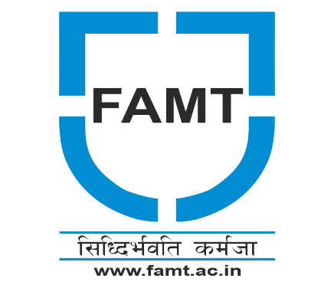

**AUGUST, 2023**

CERTIFICATE

This is to certify that the following Students have prepared and presented a report on **“E-COMMERCE WEBSITE USING MERN STACK”** as per partial fulfillment of the term work requirements for the project prescribed by University of Mumbai of Bachelor of Engineering, Year 2023-24.

Prepared by

Mr. Amberkar Rushikesh Nilesh. RD-22-0373

Mr. Fondu Afan Mubin. RD-22-0526

Mr. Joshi Raj Dilip. RD-22-0374

Mr. Shivgan Sahil Sudhir. RD-22-0371

**Prof. M. A. Jadhav Prof. V. V. Nimbalkar Dr. Kaushal Prasad**

**(Project Guide) H.O.D. (CSE-AIML) Principal**

**External Examiner**

ACKNOWLEDGEMENT

We, hereby sincerely acknowledge those who have imparted their valuable time, energy and intellectual towards the beautification of our project title as “E-commerce Website using MERN Stack”.

It gives us great pleasure to express our sincere, hearty gratitude to our guide, Prof. Mahesh Jadhav Sir Department of Computer Science and Engineering (AI & ML), FAMT, Ratnagiri for his kind interest, inspiring gratitude, valuable advice encouragement and help throughout the project work.

We must thank Prof. V. V. Nimbalkar (H.O.D) Department of Computer Science and Engineering (AI & ML), FAMT, Ratnagiri for her constant encouragement and best support for the completion of this project, others staff members, non-teaching staff of CSE Dept. who have directly and indirectly contributed to our project and encouraging us to bring this project in its present.

Mr. Amberkar Rushikesh Nilesh. RD-22-0373

Mr. Fondu Afan Mubin. RD-22-0526

Mr. Joshi Raj Dilip. RD-22-0374

Mr. Shivgan Sahil Sudhir. RD-22-0371

ABSTRACT

In today's generation, most people are using technology to lead their lives and fulfil their daily needs. In this generation, most of us are using E-commerce websites for shopping for clothes, groceries, and electronics. We have developed an E-commerce web application using MERN stack technology, which includes MongoDB, Express.JS framework, React.JS library, and Node.JS platform.

This application is fully functional with different views for users and administrators. It also integrates with a payment gateway for checkout. Using this website, we can buy various variety of products like mobile phones, clothes and electronics and choose different styles based on customer interests.

In this project, we can add different products and delete them as well. We have developed administrative functions for the website, such as creating a product, creating categories, the Admin dashboard, managing products, and managing categories.

For customers, they can quickly add items to their cart. Based on the items in the cart, the bill is generated, and the customer can pay using Stripe.

INDEX

|  |  |  |
| --- | --- | --- |
| **Sr.No** | **Topics** | **Page No.** |
| **1** | **Introduction** | **6** |
| **2** | **System Features** | **7** |
| **3** | **System Requirements** | **8** |
| **4** | **Methodology**   * **DATA FLOW DIAGRAM** * **E-R Diagram** | **9 - 11** |
| **6** | **Implementation** | **12-15** |
| **7** | **Advantages** | **16** |
| **8** | **Disadvantages** | **16** |
| **9** | **Future Scope** | **17** |
| **10** | **Conclusion** | **18** |
| **11** | **References** | **19** |

INTRODUCTION

We all know that technology has become an essential tool for online marketing these days. If we look all over the world, most people are showing interest in buying things online. However, we can see that there are many small shops and grocery stores selling their products offline. With this type of selling, most of us may face a bad experience. For instance, in some shops, the seller may have the product on offer, but the buyer may not know about it. Or, the customer may need the product urgently and go to the shop, only to find it out of stock. In such cases, they will have a bad experience. Moreover, in online shopping, customers can choose from a wide range of products based on their interests and compare prices from one store to another.

By addressing all the problems and weaknesses of the offline shopping system, creating an e-commerce web application becomes necessary for searching and shopping in each shop. These days, we have witnessed the creation of many e-commerce websites like Flipkart, Amazon, and Myntra, where one can easily purchase necessary products from the comfort of their home. By using these websites, customers can also notice the price difference between products. The cost of products tends to be slightly higher in offline shopping compared to online shopping.

To create these types of e-commerce web applications, the MERN stack is the best option, as it can help us create the most effective and powerful web applications.

SYSTEM FEATURES

* E-commerce Website using MERN Stack

The E-commerce website built on the MERN stack offers a user-friendly platform for online shopping. Users can register, browse a diverse product catalog, add items to their shopping cart, and securely complete their purchases. The website provides order management, reviews, and admin controls for product and user management. It also supports secure payment options, real-time order tracking, and multilingual support, ensuring a seamless shopping experience for customers.

Coupled with responsive design, the website ensures a smooth experience across various devices. It prioritizes security, safeguarding user data and payments. Additionally, it integrates with shipping carriers for efficient order fulfillment and offers customer support for inquiries and assistance. With SEO optimization, social integration, and personalized recommendations, this E-commerce platform strives to enhance customer engagement and satisfaction.

SYSTEM REQUIREMENTS

**HARDWARE REQUIREMENTS**

* Processor – Dual-core (2.5 GHz).
* RAM – Minimum 4GB.
* Storage – Minimum 1GB free space.
* Network – Stable internet connection.

**SOFTWARE REQUIREMENTS**

* Operating System – Windows 11
* IDE – Visual Studio Code
* Node.js – Version 1.8 or higher.
* MongoDB – Install locally or use MongoDB Atlas (Cloud Service).
* Browser - Chrome

METHODOLOGY

* THIS DESIGNED SYSTEM THAT WILL MANAGE:

1. User / Customer and Admin Registration and Login.
2. After Login comes the Home page.
3. From the home page we can search for specific product or go to products section.
4. Then comes the products whole description page.
5. On the product page there is a “Add to Cart” option.
6. Then after that there is the payment page.

* Admin MODULE:

1. Admin will register and login.
2. Admin then enters the home page from where he can edit the home page, products and many more.
3. Also, he can view and edit the products ordered by customers.

* User Module

1. User / Customer Registration and Login.
2. User / Customer will view various products on Products page.
3. User will then select the product they want to buy and add it to cart.
4. User will then go to the cart page and can increase or decrease the quantity of the product added and then proceed to pay.
5. The user has 2 options to pay i.e., COD and Credit / Debit and he can also track the order.

* **DATA FLOW DIAGRAM**

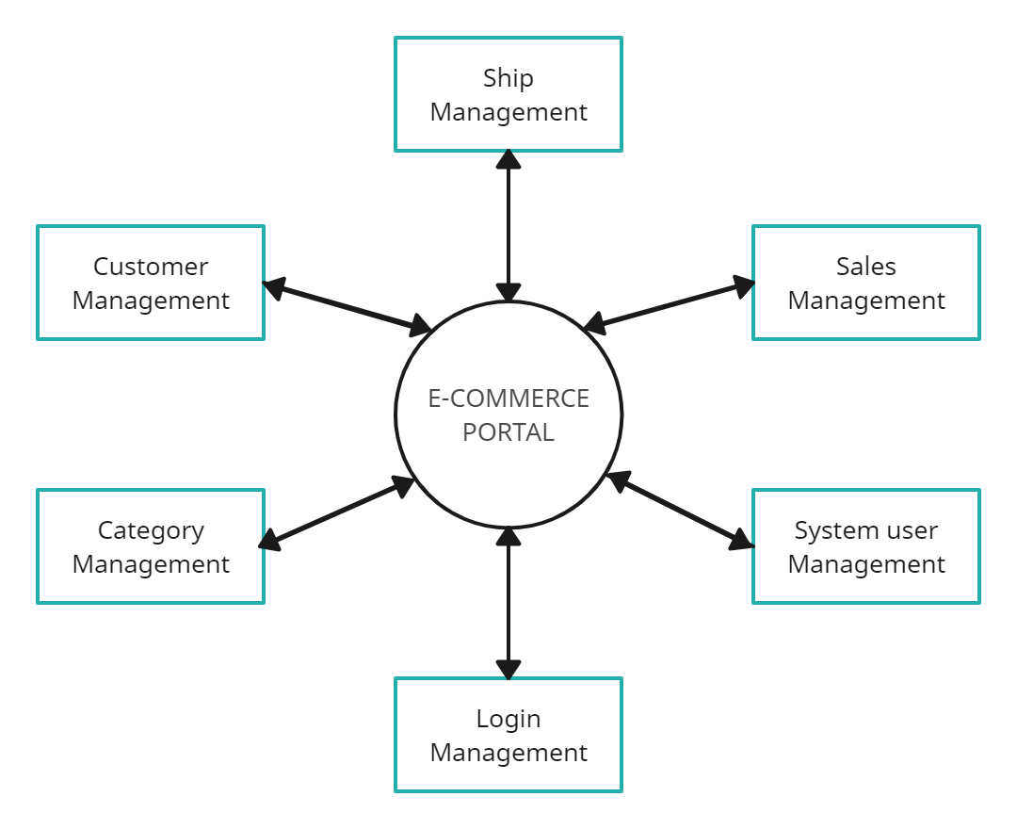

* **E-R Diagram:**

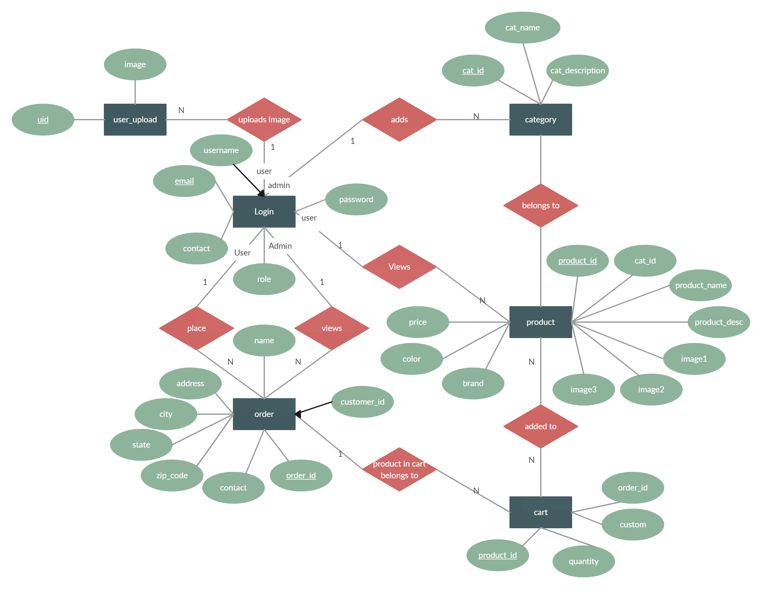

IMPLEMENTATION

* **RESULTS (SCREENSHOTS)**
* **User Module**

1. **Home Page**

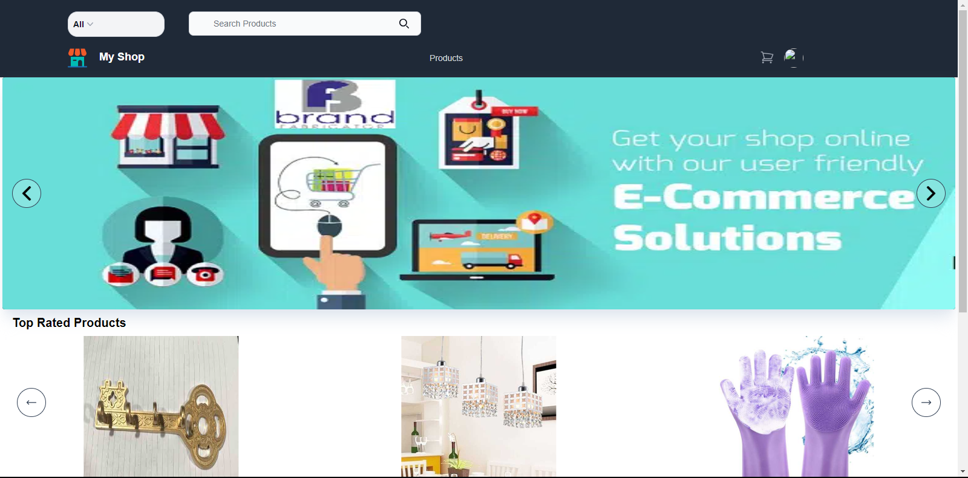

1. **Product Details**

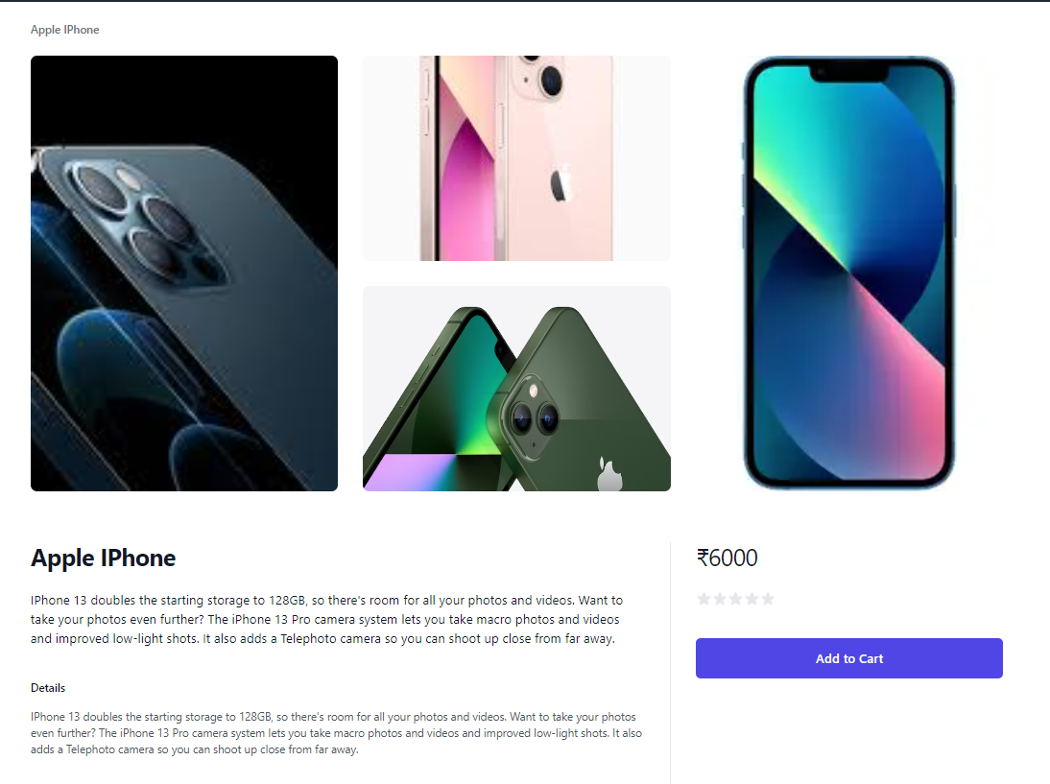

1. **Cart Page**

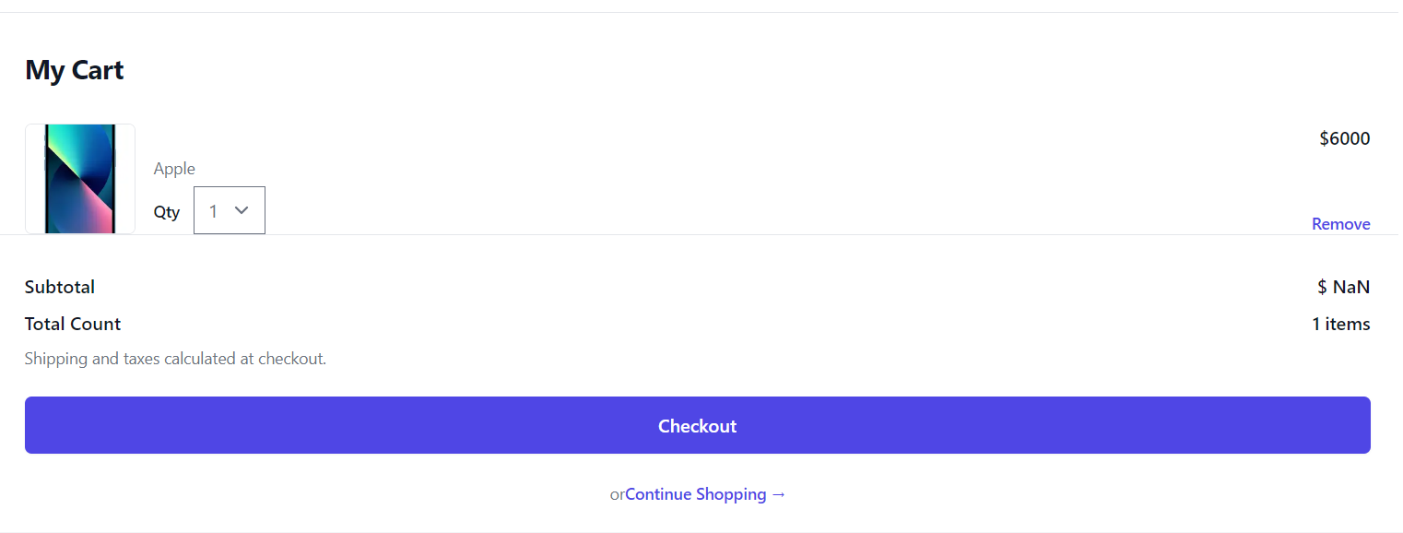

1. **Checkout Page**

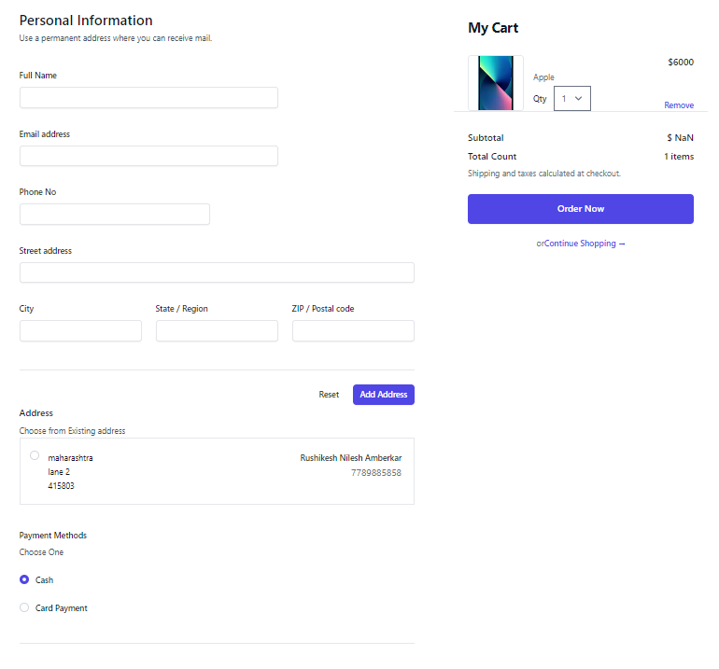

* **Admin Module**

1. **Admin Product Edit**

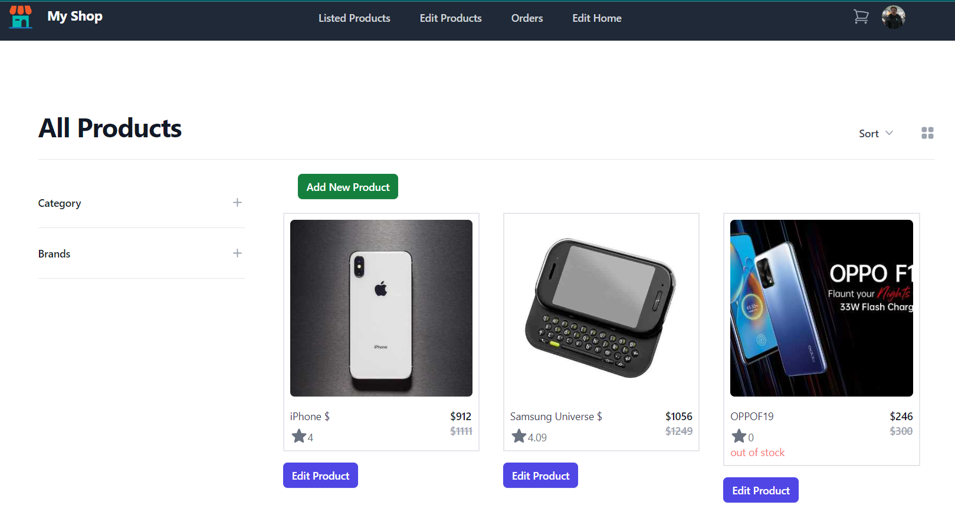

1. **Home Page Edit**

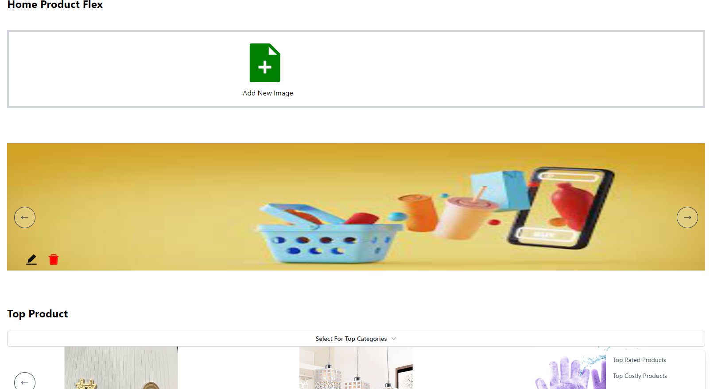

1. **Look over every order**

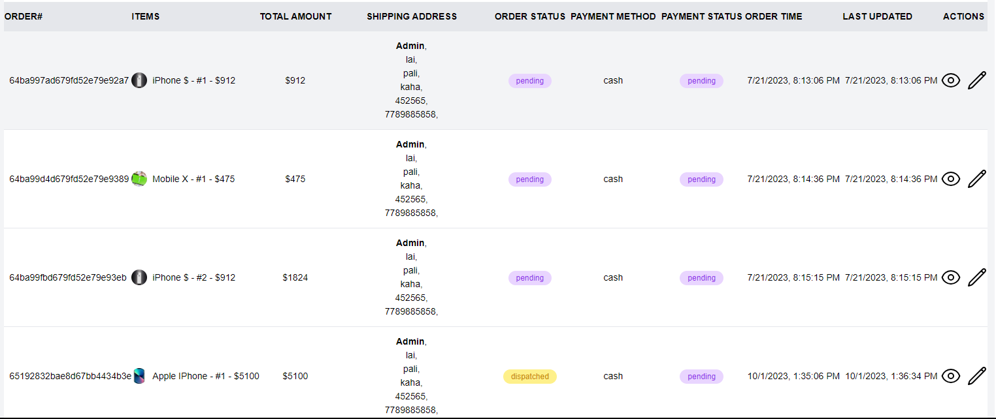

ADVANTAGES

* A Huge Market.
* Wide Product Variety.
* Convenient and Safe.
* Always Open.
* More accurate decision making.

DISADVANTAGES

* Security.
* Delaying in Delivery.
* Technology Cost.

FUTURE SCOPE

In the future, we envision enhancing the user experience and expanding the functionalities of the e-commerce website. Some of the potential areas for future development include:

1. **User Profiles**: Implementing user profiles that allow customers to save their favourite products, track their order history, and receive personalized recommendations based on their preferences.
2. **Advanced Search and Filters**: Introducing advanced search options and filters to help users quickly find their desired products, such as filtering by size, colour, price range, and more.
3. **Wishlis**t: Adding a wishlist feature that allows users to save products they're interested in for future purchase, promoting engagement and retention.
4. **Multiple Payment Options**: Incorporating a variety of secure payment options, including digital wallets and payment gateways, to cater to different customer preferences.
5. **Social Media Integration**: Integrating social media sharing options that allow users to easily share their favourite products with friends and followers, thereby increasing the website's reach.

CONCLUSION

In conclusion, our project centers on developing an advanced E-Commerce website using the MERN stack. This website offers an enhanced customer experience, benefiting both small-scale industries and large retailers by enabling direct sales and cost savings. Our technology choices prioritize project requirements, development efficiency, scalability, and security.

REFERENCES

[1] <https://developer.mozilla.org/en-US/docs/Web/JavaScript>

JavaScript Full Tutorial Documentation [Internet].

[2] <https://www.tutorialspoint.com/nodejs/nodejs_introduction.htm>

Node.js Full Tutorial Documentation [Internet].

[3] <https://www.tutorialspoint.com/expressjs/index.htm>

Express Tutorial Documentation [Internet].

[4] <https://www.mongodb.com/docs/manual/introduction/>

MongoDB Full Documentation

[5] <https://reactjs.org/docs/faq-internals.html>

Virtual DOM Tutorial Documentation [Internet].

[6] <https://react.dev/reference/react/Component>

React Components [Internet].

[7] <https://www.mongodb.com/mern-stack>

MERN Stack concept.

[8] Mai, N. (2020). E-commerce Application using MERN stack.

[9] King, D. N., & King, D. N. (2004). Introduction to e-commerce. Prentice Hall.

[10] Nemat, R. (2011). Taking a look at different types of e-commerce. World Applied Programming, 1(2), 100-104.

[11] Niranjanamurthy, M., Kavyashree, N., Jagannath, S., & Chahar, D. (2013). Analysis of e-commerce and m-commerce: advantages, limitations and security issues. International Journal of Advanced Research in Computer and Communication Engineering, 2(6), 2360-2370.

[12] Hoque, S. (2020). Full-Stack React Projects: Learn MERN stack development by building modern web apps using MongoDB, Express, React, and Node. js. Packt Publishing Ltd.